***NAME : Himanshu Dixit***

***ENROLL NO. : B64178***

***BATCH : B10***

***SOFTWARE DEVELOPMENT FUNDAMENTAL LAB-I(15B17CI171) Assignment Sheet (WEEK-4 PHASE-2)***

***Lab A***

***1.****Print* *day of week name using switch case.*

***Solution:***

*#include<stdio.h>*

*int main()*

*{*

*int week;*

*printf("Enter day of the weeek 1 to 7 : ");*

*scanf("%d",&week);*

*switch(week)*

*{*

*case 1: printf("Monday");*

*break;*

*case 2: printf("Tuesday");*

*break;*

*case 3: printf("Wednesday");*

*break;*

*case 4: printf("Thursday");*

*break;*

*case 5: printf("Friday");*

*break;*

*case 6: printf("Saturday");*

*break;*

*case 7: printf("Sunday");*

*break;*

*default: printf("invalid input");*

*}*

*return 0;*

*}*

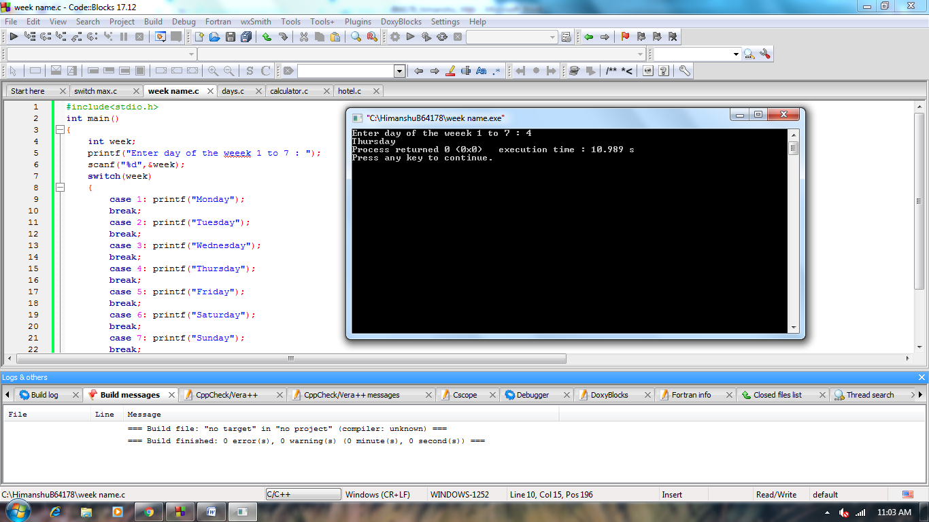

***2.****Find maximum between two numbers using switch case.*

***Solution:***

*#include<stdio.h>*

*int main()*

*{*

*int a,b;*

*printf("Enter 1st number : ");*

*scanf("%d",&a);*

*printf("Enter 2nd number : ");*

*scanf("%d",&b);*

*switch(a>b)*

*{*

*case 1: printf("%d is greater number",a);*

*break;*

*default: printf("%d is greater number",b);*

*}*

*return 0;*

*}*

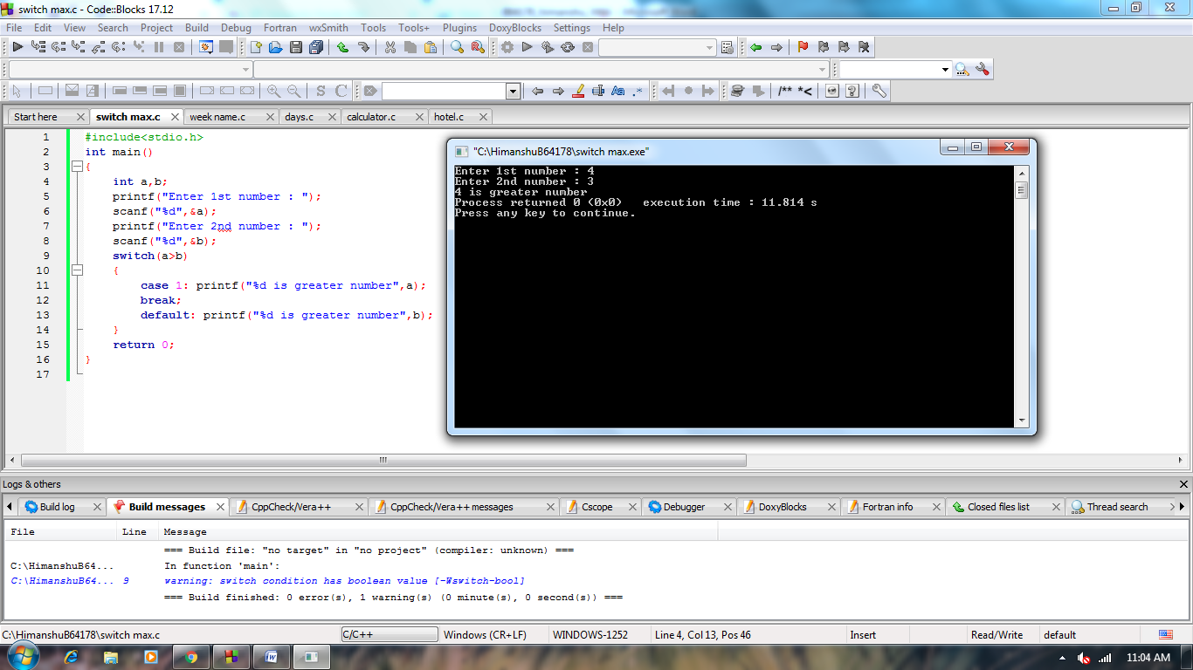

***3.****Print number of days in a month using switch case.*

***Solution:***

*#include<stdio.h>*

*int main()*

*{*

*int month;*

*printf("Enter month NO.(1 to 12): ");*

*scanf("%d",&month);*

*switch(month)*

*{*

*case 1: printf("31 days");*

*break;*

*case 2: printf("28 days");*

*break;*

*case 3: printf("31 days");*

*break;*

*case 4: printf("30 days");*

*break;*

*case 5: printf("31 days");*

*break;*

*case 6: printf("30 days");*

*break;*

*case 7: printf("31 days");*

*break;*

*case 8: printf("31 days");*

*break;*

*case 9: printf("30 days");*

*break;*

*case 10: printf("31 days");*

*break;*

*case 11: printf("30 days");*

*break;*

*case 12: printf("31 days");*

*break;*

*default:*

*printf("Invalid input ");*

*}*

*return 0;*

*}*

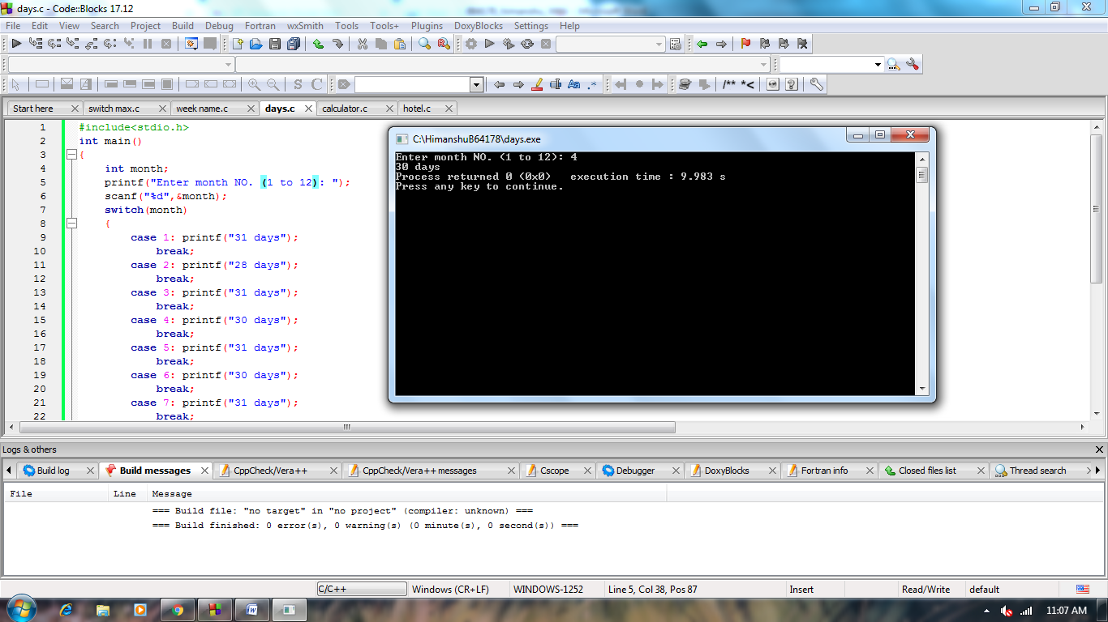

***4.****Create a calculator application which can perform addition, subtraction, multiplication and division operations. (Use switch statement in this program)*

***Solution:***

*#include<stdio.h>*

*int main()*

*{*

*int a,b,choice;*

*printf("Enter 1st number : ");*

*scanf("%d",&a);*

*printf("Enter 2nd number : ");*

*scanf("%d",&b);*

*printf("Enter your choice\n1.addition\n2.subtraction\n3.multiplication\n4.division :");*

*scanf("%d",&choice);*

*switch(choice)*

*{*

*case 1:printf("a + b = %d",a+b);*

*break;*

*case 2:printf("a - b = %d",a-b);*

*break;*

*case 3:printf("a * b = %d",a*b);*

*break;*

*case 4:printf("a / b = %f",a/b);*

*break;*

*default :printf(" invalid input");*

*}*

*return 0;*

*}*

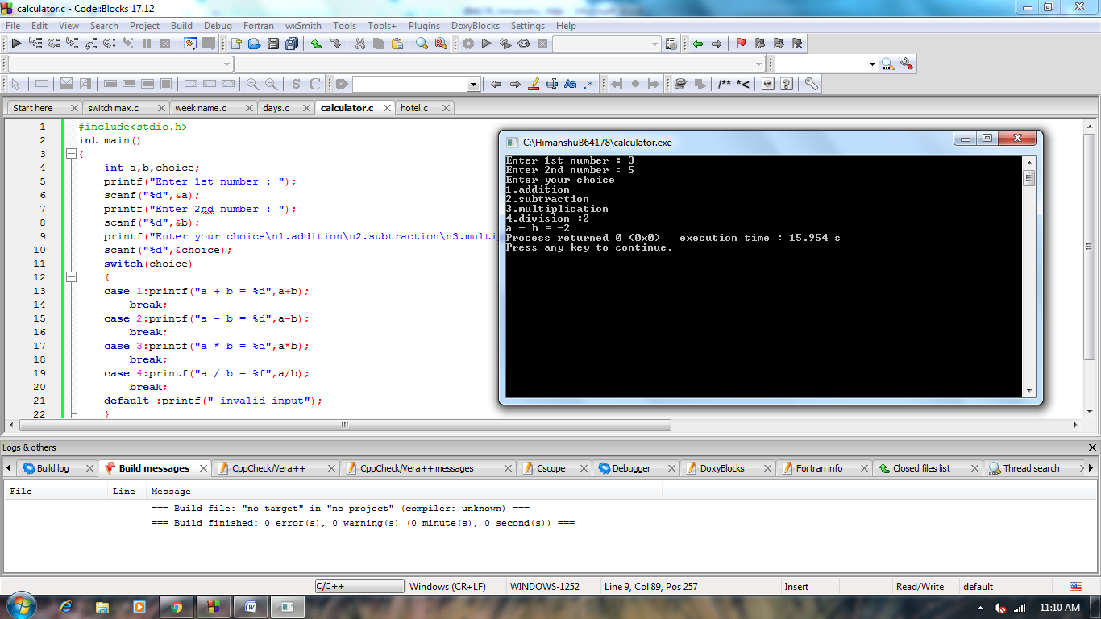

***5.****Using Switch statement, write a program that displays the following menu for the food items available to take order from the customer:  
• B= Burger  
• F= French Fries  
• P= Pizza  
• S= Sandwiches  
The program inputs the type of food and quantity. It finally displays the total charges for the order according to following criteria:  
• Burger = Rs. 200  
• French Fries= Rs. 50  
• Pizza= Rs. 500  
• Sandwiches= Rs. 150*

***Solution:***

*#include<stdio.h>*

*int main(){*

*char ss;*

*int q;*

*printf("B= Burger(RS 200)\nF= French Fries(RS 50)\nP= Pizza(RS 500)\nS= Sandwiches(RS 150)\nenter your choice : ");*

*scanf("%c",&ss);*

*printf("enter the quantity : ");*

*scanf("%d",&q);*

*switch(ss)*

*{*

*case 'B':printf("your total charges is RS %d",q*200);*

*break;*

*case 'F':printf("your total charges is RS %d",q*50);*

*break;*

*case 'P':printf("your total charges is RS %d",q*500);*

*break;*

*case 'S':printf("your total charges is RS %d",q*150);*

*break;*

*default:printf("invalid choice");*

*}*

*return 0;*

*}*

